Here are the softwares you can use in order to communicate with your board:
1. Visual Studio Code + Serial Monitor Extension
Installation
- Download VS Code: https://code.visualstudio.com/
- Open VS Code and install the Serial Monitor extension by Microsoft:
  - Click the Extensions icon
  - Search for "Serial Monitor".
  - Click Install.
  - Close and re-open VS Code
Basic Usage
- Connect your STM32 board via USB.
- If a terminal does not appear in the bottom of the screen, open the “View” tab and click on “Terminal”.
- A tab named “serial monitor” should be present among those above the terminal.
- Select the correct COM port (e.g., COM3).
- Set the baud rate (e.g., 115200).
- You’ll now see serial data printed from the STM32.
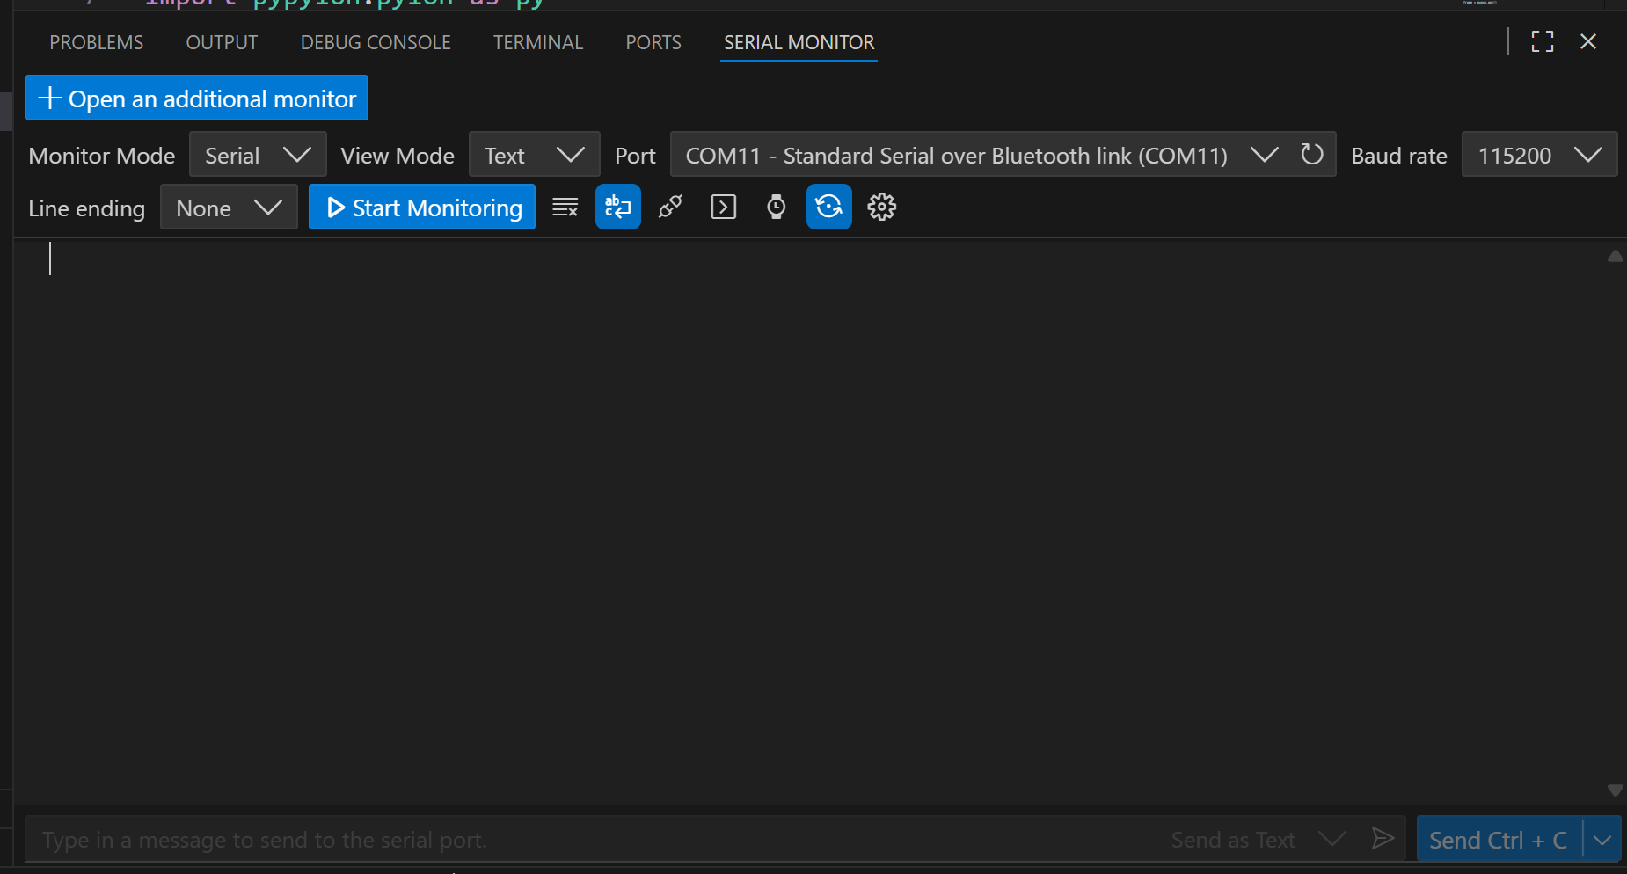

2. PuTTY
Installation
- Go to: https://www.chiark.greenend.org.uk/~sgtatham/putty/latest.html
- Download the installer or standalone putty.exe (64-bit).
- If you use putty.exe, it runs without installation (portable).
Basic Usage (Serial Communication)
- Connect your STM32 board via USB.
- Open Device Manager and find the COM port (e.g., COM3) assigned to your board.
- Launch PuTTY.
- In the startup screen:
  - Select Terminal. Fill in:
    - Select “Implicit CR in every LF”
    - Select “Implicit LF in every CR”
  - Select Serial. Fill in:
    - Serial line: COM3 (or your port)
    - Speed: 115200 (or your board’s baud rate)
- Click Open.
- A terminal window will appear: you'll see data sent from the STM32

3. Arduino IDE
Installation
- Download Arduino IDE: https://www.arduino.cc/en/software
- Install it like any other program.
Basic Usage for Serial Monitor
- Connect the STM32 board via USB.
- Open Arduino IDE.
- Go to Tools > Port and select the correct COM port.
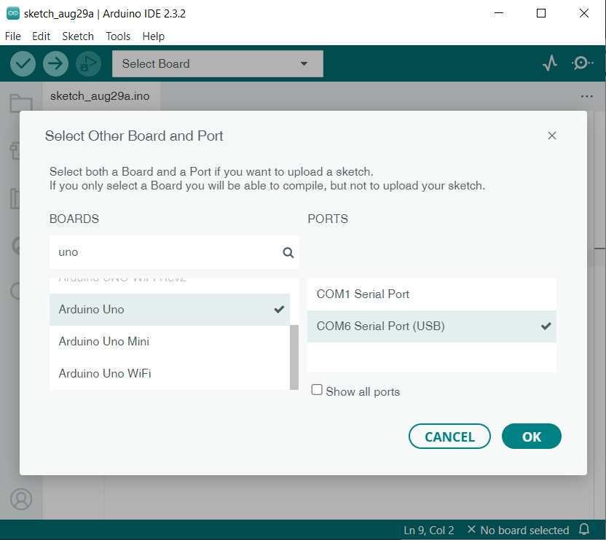
- Open the Serial Monitor via Tools > Serial Monitor.
- Choose the correct baud rate (e.g., 115200).
- You’ll see the output from the STM32’s UART.

